 [Translated from Chinese (Simplified) to English - www.onlinedoctranslator.com](https://www.onlinedoctranslator.com/en/?utm_source=onlinedoctranslator&utm_medium=doc&utm_campaign=attribution)

**EC57-K02**

**Bus type open and closed loop stepper driver**

**User Manual V1.0.0**

**Table of contents**

1. Product Introduction 1

1.1 Product Overview 1

1.2 Product Features 1

1.3 Networking Solution 2

2. Installation dimensions and interface definition 2

2.1 Mechanical installation diagram 2

2.2 Installation Notes 3

2.3 Electrical specifications 3

2.4 Operating environment and parameters 3

3. Driver interface and wiring description 4

3.1 Driver Interface Introduction 4

3.2 DIP switch 5

3.2.1 Open-loop and closed-loop mode settings 5

3.2.2 Current setting 5

3.2.3 Direction Switching Settings 5

3.3 Indicator Lights 6

3.4 EC57-K02 Communication Interface 6

3.5 Input signal interface 6

3.5.1 Input signal description and wiring diagram 6

3.5.2 Input signal interface function 8

3.5.3 Input signal interface function description 8

3.6 Output signal interface 8

3.6.1 Output signal description and wiring diagram 8

3.6.2 Output signal interface function 1

3.6.3 Output signal interface function description 1

3.7 Serial communication signal interface 1

3.8 Encoder input signal interface 1

3.9 Motor Control Output Interface 2

3.10 Power input interface 2

4. Parameter Description and Settings 3

4.1 All parameters 3

4.1.1 Communication parameters 3

4.1.2 Factory-defined parameters 4

4.1.3 Cia402 parameter group 8

4.2 IO function configuration 11

4.2.1 Input Signal 11

4.2.2 Output Signal 11

5. Common functions 12

5.1 Parameter saving and factory reset 12

5.2 Control word and status word bit definition 13

5.2.1 6040 Control Word 13

5.2.2 6041 Status Word 13

5.3 Control Mode and Associated Object Dictionary 14

5.4 State transition of each mode control operation 14

5.5 Return to origin mode 15

5.5.1 Mode 17 (Negative limit return to zero)) 16

5.5.2 Mode 18 (Positive limit return to zero)) 16

5.5.3 Mode 19 (Home Return1) 17

5.5.4 Mode 20 (origin return2) 17

5.5.5 Mode 21 (origin return3) 18

5.5.6 Mode 22 (origin return4) 18

5.5.7 Mode 23 (origin + positive limit return to zero)1) 19

5.5.8 Mode 24 (origin + positive limit return to zero)2) 20

5.5.9 Mode 25 (origin + positive limit return to zero)3) 20

5.5.10 Mode 26 (origin + positive limit return to zero)4) twenty one

5.5.11 Mode 27 (origin + negative limit return to zero)1) twenty two

5.5.12 Mode 28 (origin + negative limit return to zero)2) twenty three

5.5.13 Mode 29 (origin + negative limit return to zero)3) twenty three

5.5.14 Mode 30 (origin + negative limit return to zero)4) twenty three

5.5.15 Mode 33 (Z signal returns to zero)1) twenty four

5.5.16 Mode 34 (Z signal returns to zero)2) twenty four

5.5.17 Mode-3 (Stalling and Returning to Zero)1) 25

5.5.18 Mode-4 (Stalling and Returning to Zero)2) 25

5.5.19 Mode-5 (Stalling back to zero)3) 26

5.5.20 Mode-6 (Stalling back to zero)4) 26

5.5.21 Introduction to other zero return methods 26

6. Serial port download parameter description 27

VII. Fault codes and indicator lights 27

7.1 Drive Failure 27

7.2 EtherCAT communication alarm 27

8. Warranty and After-sales Service 28

8.1 Warranty 28

8.1.1 Free warranty 28

8.1.2 Warranty exclusion 28

8.2 Exchange 28

8.2.1 Product replacement due to product failure 28

8.2.2 Replacement for non-product failure 29

8.3 Returns 29

8.4 After-sales service 30

IX. Version Revision History 30

# Product Introduction

## 1.1 Product Overview

EC57-K02 bus-type open-closed loop integrated stepper driver adopts EtherCAT bus communication interface, integrating EtherCAT slave technology, vector control technology, built-in micro-segmentation technology, adaptive filtering technology, and closed-loop control technology, realizing real-time control and real-time data transmission of the stepper system, and optimizing the performance of the stepper motor: medium and low speeds have excellent stability and ultra-low noise; high-speed torque is greatly improved, expanding the speed application range of the stepper motor; smooth and precise pure sinusoidal current vector control technology effectively reduces motor heating.

EC57-K02 bus-type open-closed loop integrated stepper driver has perfectly supported many master control systems such as Beckhoff, Omron, Positive Motion, Inovance, Xinjie, etc., and has been widely used in textile, robotics, lithium battery equipment, 3C electronics and other industries.

## **1.2 Product Features**

●New Generation 32-bit ARM technology, high cost performance, good stability, excellent noise and vibration performance

●Adopt EtherCAT slave technology, support CIA301 and CIA402 sub-protocols, support CSP, PV, PP, HM modes

●Users can set the current, subdivision and lock current through ethercat bus or serial communication

●Built-in single-axis controller function: users can set synchronous position mode, speed mode, position mode, and homing mode through the bus

●5-way opto-isolated programmable input interface, Receive external control signals, Realize drive limit, Origin, emergency stop and other functions

●Built-in micro-segmentation

●Built-in motor parameter setting

●Any current reduction ratio can be set when stationary

●Convenient current setting

●With overvoltage, undervoltage and other protection functions

●Good stability, excellent noise and vibration performance

●Support position control, Speed ​​control etc.

●Pure sinusoidal current vector control effectively reduces motor heating

●3-way opto-isolated programmable output interface, output driver status and control signals

●With arbitrary subdivision adjustment, you can change the subdivision at will

●Closed loop can set out-of-tolerance alarm value

●Excellent stability at low frequencies and small subdivisions

●Voltage Range: DC 20-50V

## **1.3 Networking Solution**

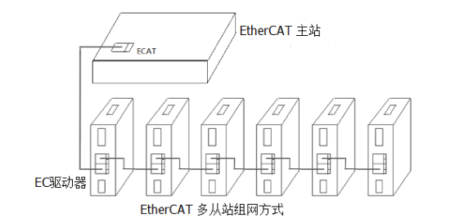

Figure 1 Bus-type stepping networking solution

# **Installation dimensions and interface definition**

## **2.1Mechanical installation drawing**

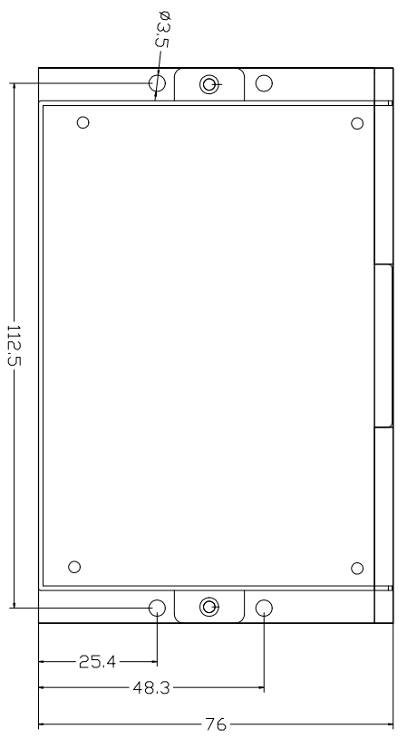 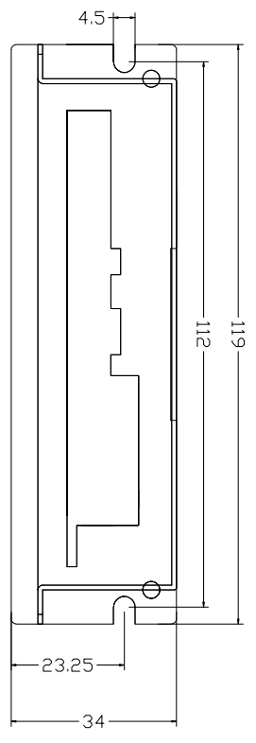

Front installation diagram Side installation diagram

Figure 2.1 Installation dimensions (unit: mm)

## **2.2 Installation Notes**

1. When installing the driver, please use side installation for better heat dissipation. When designing the installation dimensions, consider the terminal size and wiring.
2. In order to ensure good heat dissipation conditions, a larger installation interval must be reserved as much as possible during actual installation. If necessary, install a fan near the driver inside the machine to form strong air convection on the bottom of the driver to assist in heat dissipation and ensure that the driver operates within a reliable operating temperature range.

## **2.3 Electrical specifications**

|  |  |  |  |  |
| --- | --- | --- | --- | --- |
| **illustrate** | **EC57-K02 bus open and closed loop stepper driver** | | | |
| **Minimum** | **Typical Value** | **Maximum** | **unit** |
| **Output Current** | 0 | - | 6000 | mA |
| **Input power voltage** | 20 | 36 | 50 | VDC |
| **Control signal input current** | 7 | 10 | 16 | mA |
| **Insulation resistance** | 50 | - | - | MΩ |

## **2.4 Operating environment and parameters**

|  |  |  |
| --- | --- | --- |
| **Cooling method** | | Natural cooling, fan cooling |
| **Usage Environment** | **occasion** | Do not place it near other heating equipment. Avoid dust, oil mist, corrosive gas, high humidity and strong vibration. Flammable gas and conductive dust are prohibited. |
| **temperature** | -25℃~55℃ |
| **humidity** | 40~90%RH |
| **vibration** | 10~55Hz/0.15mm |
| **Storage temperature** | | -25℃~65℃ |

# **Driver interface and wiring description**

## **3.1 Driver Interface Introduction**

Table 3.1 Driver interface

|  |  |  |  |
| --- | --- | --- | --- |
| **name** | | **Function** | **illustrate** |
| Dip switch SW1-4 | | Set open/closed loop mode, current, motor rotation direction | SW1: Driver open/closed loop selection |
| SW2-3: Current selection |
| SW4: Direction switch |
| ALM | | Alarm indicator light | Overcurrent, overvoltage, phase loss, EEPROM programming error flashes |
| PWR | | Power indicator | The light is on when the power is normal |
| ECAT IN/OUT | | EtherCAT communication port | ECAT IN:  ECAT OUT: |
| IN/OUT | Xcom | Single-ended input common  Correct connection is effective | Connect to anode |
| Ycom | Single-ended output common port  Compatible with common cathode and common anode | Compatible with both common cathode and common anode connection |
| X0 | Single-ended input | Low-speed digital signal input interface |
| X1 |
| X2 |
| X3 |
| X4 |
| Y0 | Single-ended output | Low-speed digital signal output interface |
| Y1 |
| Y2 |
| UART | 3.3V | Serial communication | Download COE parameters via serial port |
| GND |
| RxD |
| TXD |
| ENCODER | ENZ+ | Encoder interface | Z signal level detection |
| ENB+ |
| ENB- |  |
| ENA+ |
| ENA- |
| VCC |
| GND |  | Negative terminal of encoder 5V power supply |
| A+ |  |
|  | A- |  |  |
| B+ |
| B- |
| VDC |
|  | GND |  |  |
|  |

## **3.2 DIP switch**

Table 3.2 DIP switch function description

|  |  |  |
| --- | --- | --- |
| **name** | **Function** | **illustrate** |
| Dip switch SW1-SW4 | Set open/closed loop mode, current, motor rotation direction | SW1: Driver open/closed loop selection |
| SW2-SW3: Current selection |
| SW4: Direction switch |

### **3.2.1 Open-loop and closed-loop mode settings**

The open-loop and closed-loop modes can be selected by using the DIP switch SW1, as shown in the table below.

Table 3.3 Open-loop and closed-loop mode settings

|  |  |
| --- | --- |
| **SW1** | **Working Mode** |
| off | Open Loop |
| on | closed loop |

### **3.2.2 Current setting**

In both open and closed loop modes, the current can be set by dialing SW2-SW3. There are 4 currents to choose from, which are compatible with motors of 42-86. If the user needs to adjust the current by himself, he can do so through the host computer software or the ECAT master station.SW2-SW3 must be turned off to adjust.

Table 3.4 Current setting

|  |  |  |  |  |  |
| --- | --- | --- | --- | --- | --- |
| **SW2** | **SW3** | **Open Loop** | | **closed loop** | |
| Peak | RMS | Imin | Imax |
| off | off | 1.0 | 0.7 | 0.2 | 0.7 |
| on | off | 2.1 | 1.5 | 0.3 | 1.2 |
| off | on | 4.2 | 3.0 | 0.5 | 2.5 |
| on | on | 5.6 | 4.0 | 1.0 | 4.8 |

### **3.2.3 Direction Switching Settings**

The user can select the initial rotation direction of the motor by dialing SW4.As shown in the following table.

Table 3.5 Direction switching settings

|  |  |
| --- | --- |
| **SW4** | **Initial rotation direction** |
| off | Positive direction |
| on | Reverse direction |

## **3.3 Indicator Lights**

EC57-K02 bus type open and closed loop integrated stepper driverThe indicator light is a retracted SMD LED. There is a small cutout on the driver to observe the indicator light status. Its basic definition is shown in Table 3.6 below.

Table 3.6 Definition of indicator lights

|  |  |  |  |
| --- | --- | --- | --- |
| **name** | **describe** | **Function** | **illustrate** |
| ALM | Red LED | Power supply, parameter saving function indication, factory reset function indication, dial status switching indication,  Alarm indicator light | When the power is on normally, the green light is always on and the red light is off.  When saving parameters, restoring factory settings, switching the dial status, or the device is abnormal, the red light will flash to alarm. For the flashing pattern, please refer to Chapter 7. |
| PWR | Green LED |

## **3.4 EC57-K02 Communication Interface**

EC57-K02 bus type open and closed loop integrated stepper driverThe communication interface uses a one-piece standard RJ45 socket, as shown in Figure 3.1. The left port is the input port, connected to the output port of the previous driver; the right port is the output port, connected to the input port of the next driver.

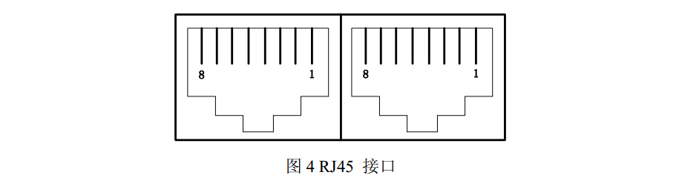

Figure 3.1 Schematic diagram of one-piece RJ45 interface

## **3.5 Input signal interface**

### **3.5.1 Input signal description and wiring diagram**

EC57-K02 bus type open and closed loop integrated stepper driverProvides a programmable interface with opto-isolated input.

The input interface adopts common anode connection and only supports NPN wiring mode. It is connected to +24V externally. To ensure reliable conduction of the internal optocoupler of the driver, the driving current of the controller end is required to be at least 10mA, and the input level pulse width needs to be greater than 10ms, otherwise the driver may not respond normally. The wiring diagram is shown in Figures 3.2 and 3.3.

After the driver is powered on normally, the effective level of the input interface is initially set to the rising edge or high level by default.The user can also configure the effective level of the input interface to be initially set to falling edge or low level by default through the master station. For specific configuration, please refer to the definition and description of the registers in Section 4.2.

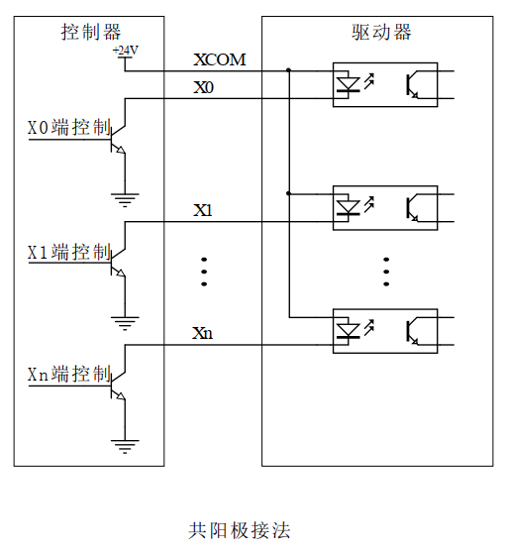

Figure 3.2 Input signal wiring diagram

Taking the NPN sensor as an example, the wiring diagram of its connection to the driver X0 terminal is as follows:

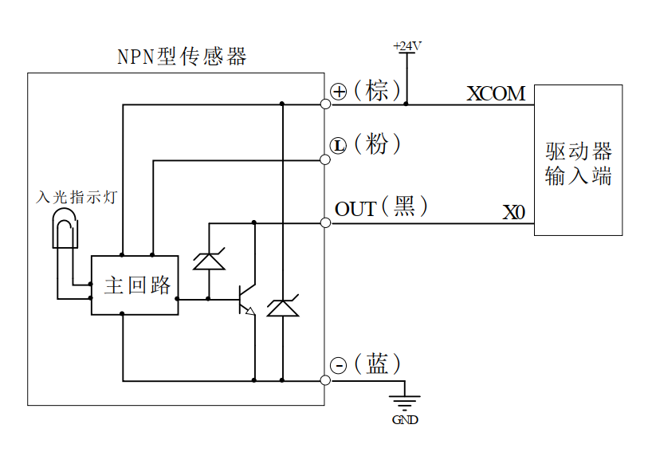

Figure 3.3 NPN sensor wiring diagram

**Note: The default input interface of the EC57-K01 bus-type open-closed loop integrated stepper driver supports 24V signals. If the user needs 5V signal control, it is necessary to communicate with our sales or technical personnel to make changes.**

### **3.5.2 Input signal interface function**

EC57-K01 bus type open and closed loop integrated stepper driver, its input port contains a variety of configurable functions. Users can set the corresponding input IO port function through the host computer. Each input IO port can be set up to 5 functions, as shown in Table 3.7 below.Refer to the description in section 4.2.

Table 3.7 Input interface function definition

|  |  |  |  |
| --- | --- | --- | --- |
| **name** | | **illustrate** | **Functional Description** |
| IN | X0 | Low speed digital signal  Input Interface | 1: Origin signal  2: Positive limit 4: Negative limit  8: Quick stop 16: Custom |
| X1 |
| X2 |
| X3 |
| X4 |
| XCOM | Single-ended input common  Correct connection is effective | Connect to +24V signal |

### **3.5.3 Input signal interface function description**

The input signal interface function description is shown in Table 3.8 below:

Table 3.8 Input interface function description

|  |  |
| --- | --- |
| **Function** | **describe** |
| 1: Origin signal | Connect the origin sensor; |
| 2: Positive limit signal | Connect the positive limit sensor; |
| 4: Negative limit signal | Connect to negative limit sensor; |
| 8: Quick stop signal | Stop the motor; |
| 16: Custom | Users can customize the function of a certain port; |

## **3.6 Output signal interface**

### **3.6.1 Output signal description and wiring diagram**

EC57-K01 bus type open and closed loop integrated stepper driverProvides a programmable interface with opto-isolated output.

The output interface is compatible with common-cathode and common-anodal connection, supports both NPN and PNP wiring, and can support high-level and low-level valid master controllers.

After the driver is powered on normally, the effective state of the output interface is initially defaulted to normally open output.The user can also configure the effective state of the output interface through the master station. The initial default is normally closed output. For specific configuration, please refer to the definition and description of the registers in Chapter 4.2.

The following figure is a wiring diagram of the output signal interface:

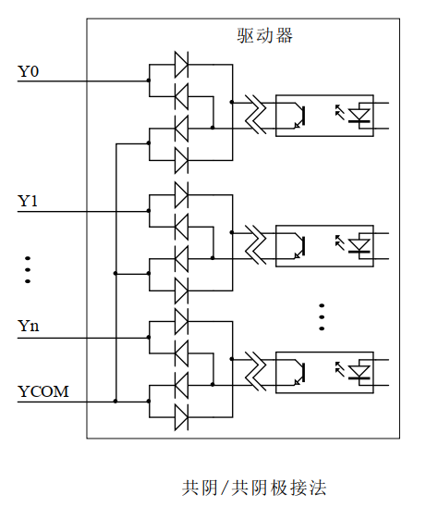

Figure 3.4 Schematic diagram of output signal wiring

### **3.6.2 Output signal interface function**

EC57-K01 bus type open and closed loop integrated stepper driver, its output port contains a variety of configurable functions. Users can set the corresponding output IO port function through the host computer. Each output IO port can be set up to 4 functions, as shown in Table 3.9 below.Refer to the description in section 4.2.

Table 3.9 Output interface function definition

|  |  |  |  |
| --- | --- | --- | --- |
| **name** | | **illustrate** | **Functional Description** |
| OUT | Y0 | Low speed digital signal  Output Interface | 1: Alarm output 2: Output in place  4: Z signal output 8: Master control output (default) |
| Y1 |
| Y2 |
| YCOM | Single-ended output common port  Compatible with common cathode and common anode | Compatible with both common cathode and common anode connection |

### **3.6.3 Output signal interface function description**

The output signal interface function description is shown in Table 3.10 below:

Table 3.10 Output interface function description

|  |  |
| --- | --- |
| **Function** | **describe** |
| 1: Alarm output signal | When the driver is in alarm state, the signal output is valid; |
| 2: Output signal when in position | When the planned trajectory is completed in position mode, the signal output is valid; |
| 4: Z signal output | Output encoder's Z signal status; |
| 8: Master control output (default) | The master station can control the output of a certain port; |

## **3.7 Serial communication signal interface**

|  |  |  |  |
| --- | --- | --- | --- |
| **name** | | **illustrate** | **Function** |
| UART | RxD | Serial communication interface | Connect to the serial communication interface, and cross-connect with the external serial signal line |
| TXD |
| 3.3V | Serial communication power interface | 3.3V power supply positive terminal |
| GND | 3.3V power supply negative terminal |

## **3.8 Encoder input signal interface**

|  |  |  |  |
| --- | --- | --- | --- |
| **name** | | **illustrate** | **Function** |
| Encoder | ENZ+ | Encoder interface | Connect the encoder A, B, Z signals, pay attention to the line sequence |
| ENZ- |
| ENB+ |
| ENB- |
| ENA+ |
| ENA- |
| VCC | Encoder power interface | Encoder 5V power supply positive terminal |
| GND | Negative terminal of encoder 5V power supply |

## **3.9 Motor Control Output Interface**

|  |  |  |  |
| --- | --- | --- | --- |
| **name** | | **illustrate** | **Function** |
| Motor | A+ | Motor interface | Two-phase stepper motor connection port  If it is a closed-loop motor, pay attention to the line sequence |
| A- |
| B+ |
| B- |

## **3.10 Power input interface**

|  |  |  |  |
| --- | --- | --- | --- |
| **name** | | **illustrate** | **Function** |
| VDC | VDC | Power interface | Power Input  DC20V~50V |
| GND |

# **Parameter Description and Settings**

## **4.1 All parameters**

### 4.1.1 Communication parameters

|  |  |  |  |  |  |  |  |
| --- | --- | --- | --- | --- | --- | --- | --- |
| **index** | **Sub-index** | **name** | **illustrate** | **type** | **property** | **default value** | **scope** |
| 1000 | 0 | Device Type | Consistent with CIA regulations | UINT32_t | RO | 0x04020192 | 0~0xFFFFFFFF |
| 1001 | 0 | Error register |  | UINT8_t | RO | 0 | 0~255 |
| 1008 | 0 | Device Name | Mainly product silk screen printing | str | RO | EC57-K01 | 0~32767 |
| 1009 | 0 | Hardware version | PCB version | str | RO | - | 0~32767 |
| 100A | 0 | Software Version | Version of the burning program | str | RO | - | 0~32767 |
| 1010 | 00 | Number of sub-indexes | .. | UINT16_t | RO | 4 | 0~32767 |
| 01 | Save all parameters | Save command: 0x65766173 | UINT32_t | R W | 0 | 0~0xFFFFFFFF |
| 02 | Save communication parameters | Same as above | UINT32_t | R W | 0 | 0~0xFFFFFFFF |
| 03 | Save factory parameters | Same as above | UINT32_t | R W | 0 | 0~0xFFFFFFFF |
| 04 | Save motion parameters | Same as above | UINT32_t | R W | 0 | 0~0xFFFFFFFF |
| 1011 | 0 | Number of sub-indexes | .. | UINT16_t | RO | 4 | 0~32767 |
| 01 | Restore all parameters to factory values | Read command: 0x64616f6c | UINT32_t | R W | 0 | 0~0xFFFFFFFF |
| 02 | Restore communication parameters to factory values | Same as above | UINT32_t | R W | 0 | 0~0xFFFFFFFF |
| 03 | Restore motion parameters to factory values | Same as above | UINT32_t | R W | 0 | 0~0xFFFFFFFF |
| 04 | Restore user parameters to factory values | Same as above | UINT32_t | R W | 0 | 0~0xFFFFFFFF |
| 1018 | 00 | Number of sub-indexes | .. | UINT16_t | RO | 4 | 0~32767 |
| 01 | Manufacturer ID | Supplier ID Number | UINT32_t | RO | - | 0~0xFFFFFFFF |
| 02 | Product Code |  | UINT32_t | RO | 0x69673537 | 0~0xFFFFFFFF |
| 03 | Modify the code |  | UINT32_t | RO | - | 0~0xFFFFFFFF |
| 04 | Serial Number |  | UINT32_t | RO | - | 0~0xFFFFFFFF |
| 1600 | 00 | Number of sub-indexes | The default number of PDO mapping objects | UINT16_t | R W | 3 | 0~32767 |
| 01-08 | RXPDO mapping object group 1 | Default RXPDO mapping object | UINT32_t | R W | .. | 0~0xFFFFFFFF |
| 1601 | 00 | Number of sub-indexes | The default number of PDO mapping objects | UINT16_t | R W | 6 | 0~32767 |
| 01-08 | RXPDO mapping object group 2 | Default RXPDO mapping object | UINT32_t | R W | .. | 0~0xFFFFFFFF |
| 1602 | 00 | Number of sub-indexes | The default number of PDO mapping objects | UINT16_t | R W | 5 | 0~32767 |
| 01-08 | RXPDO mapping object group 3 | Default RXPDO mapping object | UINT32_t | R W | .. | 0~0xFFFFFFFF |
| 1603 | 0 | Number of sub-indexes | The default number of PDO mapping objects | UINT16_t | R W | 7 | 0~32767 |
| 01-08 | RXPDO mapping object group 4 | Default RXPDO mapping object | UINT32_t | R W | .. | 0~0xFFFFFFFF |
| 1A00 | 0 | Number of sub-indexes | The default number of PDO mapping objects | UINT16_t | R W | 6 | 0~32767 |
| 01-08 | TXPDO mapping object group 1 | Default TXPDO mapping object | UINT32_t | R W | .. | 0~0xFFFFFFFF |
| 1A01 | 0 | Number of sub-indexes | The default number of PDO mapping objects | UINT16_t | R W | 5 | 0~32767 |
| 01-08 | TXPDO mapping object group 2 | Default TXPDO mapping object | UINT32_t | R W | .. | 0~0xFFFFFFFF |
| 1C00 | 00 | Number of sub-indexes |  | UINT16_t | RO | 4 | 0~32767 |
| 01 | Mailbox output type |  | UINT8_t | RO | 1 | 0~255 |
| 02 | Email Input Type |  | UINT8_t | RO | 2 | 0~255 |
| 03 | Process data output type |  | UINT8_t | RO | 3 | 0~255 |
| 04 | Process data input type |  | UINT8_t | RO | 4 | 0~255 |
| 1C12 | 0-04 | PXPDO Assignment |  | UINT16_t | R W | 1600 | 0~32767 |
| 1C13 | 0-02 | TXPDO assignment |  | UINT16_t | R W | 1A00 | 0~32767 |
| 1C32 | 0-0A | RXPDO management parameters |  | UINT16_t | RO | .. | 0~32767 |
| 1C33 | 0-0A | TXPDO management parameters |  | UINT16_t | RO | .. | 0~32767 |

### 4.1.2 Factory-defined parameters

|  |  |  |  |  |  |  |  |
| --- | --- | --- | --- | --- | --- | --- | --- |
| **index** | **Sub-index** | **name** | **illustrate** | **type** | **property** | **default value** | **scope** |
| 2000 | 0 | Slave Address | Set the slave address by yourself through the serial port;  Please note the setting of 2001H; | UINT16_t | R/W/S | 1 | 0~65535 |
| 2001 | 0 | Slave address source | 0: From the address assigned by the master station 1: From the address set at 2000H | UINT16_t | R/W/S | 0 | 0~1 |
| 2002 | 0 | Open and closed loop motor running direction | When SW4 is OFF, the initial running direction of the motor can be set through the master station;  0: The motor direction remains unchanged 1: The motor direction is reversed | UINT16_t | R/W/S | 0 | 0~1 |
| 2003 | 1 | Open loop lock machine current reduction time | After stopping operation, the flow reduction time  Unit: ms | UINT16_t | R/W/S | 500 | 10~3000 |
| 2 | Open loop lock machine current reduction percentage | After stopping operation, the lock current percentage  unit:% | UINT16_t | R/W/S | 50 | 0~100 |
| 2004 | 0 | Open loop peak current setting | When SW2-SW3 are all OFF, the open-loop peak current can be set through the master station;  Unit: mA | UINT16_t | R/W/S | 1400 | 100~7000 |
| 2005 | 0 | Open and closed loop subdivision settings | The number of pulses required for one revolution;  Unit: Pul/rev | UINT16_t | R/W/S | 10000 | 6400~51200 |
| 2006 | 0 | Open and closed loop lock machine enable  set up | 0: Unlock the device 1: Lock the device | UINT16_t | R/W/S | 0 | 0~1 |
| 2007 | 0 | Current loop self-regulation enabled | Current loop PI power-on self-tuning function: 0: Enable  1: Disable | UINT16_t | R/W/S | 0 | 0~1 |
| 2008 | 0 | Open and closed loop current loop KP | When auto-tuning is enabled, this item is read-only; When disabled, users can rewrite | UINT16_t | R/W/S | 6000 | 50~32767 |
| 2009 | 0 | Open and closed loop current loop KI | When auto-tuning is enabled, this item is read-only; When disabled, users can rewrite | UINT16_t | R/W/S | twenty four | 10~2000 |
| 200A | 0 | Open and closed loop current loop Kc | Automatically acquired, no modification by customers allowed | UINT16_t | R/S | - | 0~32767 |
| 200B | 0 | Open loop electric lock shaft duration | Unit: ms | UINT16_t | R/W/S | 50 | 10~3000 |
| 200C | 0 | Open loop electric lock shaft duration selection | 0: Default axis lock duration  1: 200BH setting duration | UINT16_t | R/W/S | 0 | 0~1 |
| 200D | 0 | Bus voltage | Unit: mV | UINT16_t | R | - | 0~65535 |
| 200E | 0 | Out-of-tolerance alarm enable | 0: Disable the out-of-tolerance alarm 1: Enable the out-of-tolerance alarm | UINT16_t | R/W/S | 1 | 0~1 |
| 200F | 0 | Out-of-tolerance alarm value | Set the out-of-tolerance alarm angle value  1 represents 0.09°, 1000 represents 90° | UINT16_t | R/W/S | 1000 | 0~4000 |
| 2010 | 0 | Total number of external positions H | The accumulated value of the received position command  High 16 bits (reserved temporarily) | UINT16_t | R | 0 | 0~65535 |
| 2011 | 0 | Total number of external locations L | The accumulated value of the received position command  Lower 16 bits (reserved temporarily) Note: Write 1 to clear the counter | UINT16_t | R/W | 0 | 0~65535 |
| 2012 | 0 | Speed ​​limit | Used to determine whether the received command speed exceeds the speed limit;  Unit: rpm | UINT16_t | R/W | 3000 | 0~3000 |
| 2013 | 0 | Automatic movement after power on | 0: Normal standby after power-on 1: After power-on, the motor rotates forward 30° and then reverses 15° to enter standby mode | UINT16_t | R/W/S | 0 | 0~1 |
| 2014 | 0 | Input IO status | Bit0 corresponds to the state of input port X0, bit1 corresponds to the state of input port X1, and so on. | UINT16_t | R | - | 0~65535 |
| 2015 | 0 | FIR filter enable | 0: No filtering, 1: Filtering  (Temporarily reserved) | UINT16_t | R/W/S | 0 | 0~1 |
| 2016 | 0 | FIR filter time constant | Unit: ms  (Temporarily reserved) | UINT16_t | R/W/S | 0 | 50~25600 |
| 2017 | 0 | True speed reference | Corresponding object dictionary 0x606C | UINT16_t | R | 0 | 0~32767 |
| 2018 | 0 | Position error value | Deviation between encoder and command | INT16_t | R | 0 | -32767~32767 |
| 2019 | 0 | Open-loop and closed-loop mode switching | When SW1 is OFF, the open-loop and closed-loop modes can be switched through the master station;  0: Open loop control  1: Closed-loop control | UINT16_t | R/W/S | 0 | 0~32767 |
| 201A | 1 | Driver software version |  | UINT16_t | R | - | 0~32767 |
| 2 | Hardware version |  | UINT16_t | R | - | 0~32767 |
| 3 | Bus level software version |  | UINT16_t | R | - | 0~32767 |
| 201B | 0 | Fault detection enable configuration | Software fault detection enable configuration; bit0: overcurrent bit1: overvoltage bit2: EEPROM bit3: instruction overspeed bit11: op amp fault  0: Disable this fault detection  1: Enable corresponding fault detection | UINT16_t | R/W/S | 15 | 0~65535 |
| 201C | 1 | Fault List 1 | The latest alarm record, the others are historical alarm records | UINT16_t | R | - | 0~65535 |
| 2 | Fault List 2 | An alarm before fault list 1 | UINT16_t | R | - | 0~65535 |
| 3 | Fault List 3 | An alarm before fault list 2 | UINT16_t | R | - | 0~65535 |
| 4 | Fault List 4 | An alarm before fault list 3 | UINT16_t | R | - | 0~65535 |
| 5 | Fault List 5 | An alarm before fault list 4 | UINT16_t | R | - | 0~65535 |
| 6 | Fault List 6 | An alarm before fault list 5 | UINT16_t | R | - | 0~65535 |
| 7 | Fault List 7 | An alarm before fault list 6 | UINT16_t | R | - | 0~65535 |
| 8 | Fault List 8 | An alarm before fault list 7 | UINT16_t | R | - | 0~65535 |
| 9 | Fault List 9 | An alarm before fault list 8 | UINT16_t | R | - | 0~65535 |
| 201D | 0 | Clear fault record enable bit selection | 0: Do not clear historical fault records  1: Clear historical fault records | UINT16_t | R/W | 0 | 0~1 |
| 201E | 0 | Clear the current fault enable bit selection | 0: Do not clear the current fault  1: Clear the current fault | UINT16_t | R/W | 0 | 0~1 |
| 201F | 0 | Motor does not work  Query | 0x2: Command overspeed | UINT16_t | R | - | 0~32767 |
| 2020 | 0 | Mode 1: In-place query | 0: Planning is completed and the arrival is in place 10: The arrival signal comes from the drive | UINT16_t | R | - | 0~32767 |
| 2021 | 0 | Input digital IO port level polarity configuration | bit0: input port X0 polarity  bit1: input port X1 polarity  And so on;  bit5-bit15: Reserved  And so on  0: unchanged 1: inverted | UINT16_t | R/W/S | 0 | 0~65535 |
| 2022 | 1 | Input digital IO port X0 function selection | Each bit of the sub-index corresponds to a function selection. For example, if the input port X0 is set to the positive limit function, the value of 2022:1 is set to 0x0002.  bit0: origin signal  bit1: positive limit bit2: negative limit  bit3: quick stop bit4: custom  bit5-bit15: Reserved  Seechapter'3.2.1 Input Signal'Description within; | UINT16_t | R/W/S | 4 | 0~255 |
| 2 | Input digital IO port X1 function selection | UINT16_t | R/W/S | 2 | 0~255 |
| 3 | Input digital IO port X2 function selection | UINT16_t | R/W/S | 1 | 0~255 |
| 4 | Input digital IO port X3 function selection | UINT16_t | R/W/S | 8 | 0~255 |
| 5 | Input digital IO port X4 function selection | UINT16_t | R/W/S | 0 | 0~255 |
| 2023 | 1 | Input digital IO port X0 filter time | Set the filter time of input ports X0-X4;  Unit: us | UINT16_t | R/W/S | 1000 | 50~60000 |
| 2 | Input digital IO port X1 filter time | UINT16_t | R/W/S | 1000 | 50~60000 |
| 3 | Input digital IO port X2 filter time | UINT16_t | R/W/S | 1000 | 50~60000 |
| 4 | Input digital IO port X3 filter time | UINT16_t | R/W/S | 1000 | 50~60000 |
| 5 | Input digital IO port X4 filter time | UINT16_t | R/W/S | 1000 | 50~60000 |
| 2024 | 0 | Output port polarity configuration | bit0: output port Y0 polarity  bit1: output port Y1 polarity  bit2: output port Y2 polarity  bit3-bit15: Reserved  0: low level 1: high level  Seechapter'3.2.2 Output signal'Description within; | UINT16_t | R/W/S | 0 | 0~65535 |
| 2025 | 1 | Output port Y0 function settings | Each bit of the sub-index corresponds to a function selection. For example, if you set the output port Y0 to the in-place output function, then set the value of 2025:1 to 0x0001.  bit0: alarm output bit1: in-place output  bit2: Z signal output bit4: Master control output (default)  bit3, bit5-bit15: reserved  Seechapter'3.2.2 Output signal'Description within; | UINT16_t | R/W/S | 16 | 0~255 |
| 2 | Output port Y1 function settings | UINT16_t | R/W/S | 16 | 0~255 |
| 3 | Output port Y2 function settings | UINT16_t | R/W/S | 16 | 0~255 |
| 2030 | 0 | Save/Restore Manufacturer parameters | bit0: save factory parameters bit1: restore factory parameters to factory settings Note: Only used for serial port download parameters.  There is no such parameter in COE | UINT16_t | W/S | 0 | 0~255 |

### 4.1.3 Cia402 parameter group

|  |  |  |  |  |  |  |  |
| --- | --- | --- | --- | --- | --- | --- | --- |
| **index** | **Sub-index** | **name** | **illustrate** | **type** | **property** | **default value** | **scope** |
| 603F | 0 | Fault Codes | See chapter for details'5. Fault code description'Description within; | UINT16_t | RO | - | 0~65535 |
| 6040 | 0 | Control Word | See chapter for details'6.3.1 6040 Control Word'Description within; | UINT16_t | R W | 0 | 0~65535 |
| 6041 | 0 | Status word | See chapter for details'6.3.2 6041 Status Word'Description within; | UINT16_t | RO | - | 0~65535 |
| 605A | 0 | Quick Stop Code | 0: Invalid  1: Emergency stop allowed | UINT16_t | R W | 1 | 0~65535 |
| 6060 | 0 | Operation mode settings | 1: PP (position mode)  3: PV (speed mode)  6: HM (home mode)  8: CSP (Cyclic Synchronous Position Mode) | USINT | R W | 8 | 0~255 |
| 6061 | 0 | Run mode status | Query the status of 6060H;  1: PP (position mode)  3: PV (speed mode)  6: HM (return to far point mode)  8: CSP (Cyclic Synchronous Position Mode) | USINT | RO | - | 0~255 |
| 6064 | 0 | Physical location | Actual motor position, unit: Pul | DINT | RO | - | -2147483647~  2147483647 |
| 606C | 0 | Actual speed | Current motor speed, unit: Pul/s | DINT | RO | - | -2147483647~  2147483647 |
| 607A | 0 | Target location | Set the total pulse number of PP (position mode);  Unit: pul | DINT | R W | 0 | -2147483647~  2147483647 |
| 607C | 0 | Origin offset | Set the origin offset of HM (home mode);  Unit: Pul | DINT | R W | 0 | -2147483647~  2147483647 |
| 60FF | 0 | Target speed | Set the maximum speed of PV (speed mode);  Unit: Pul/s | DINT | R W | 0 | -2147483647~  2147483647 |
| 6081 | 0 | Trapezoidal speed | Set the maximum speed of PP (position mode);  Unit: Pul/s | DINT | R W | 50000 | -2147483647~  2147483647 |
| 6082 | 0 | Start and stop speed | Set the start and stop speed of PP (position mode);  Unit: Pul/s | DINT | R W | 0 | -2147483647~  2147483647 |
| 6083 | 0 | Acceleration | Set the acceleration of PP (position mode) and PV (velocity mode);  Unit: Pul/s^2 | DINT | R W | 500000 | -2147483647~  2147483647 |
| 6084 | 0 | Deceleration | Set the deceleration of PP (position mode) and PV (speed mode);  Unit: Pul/s^2 | DINT | R W | 500000 | -2147483647~  2147483647 |
| 6085 | 0 | Emergency stop deceleration | Set the emergency stop deceleration of PP (position mode), PV (velocity mode), and HM (home mode);  Unit: Pul/s^2 | DINT | R W | 5000000 | -2147483647~  2147483647 |
| 6098 | 0 | Return to origin method | Currently, the values ​​that can be set for the return to origin method are: (-1)~(-6), 1~14, 17~30, 33, 34, 35, 37;  See chapter for details'5.5 Return to origin mode method'Description within; | SUINT | R W | 0 | 0~255 |
| 6099 | 01 | Origin search speed 1 | HM (home mode) origin search speed 1: high speed origin search;  Unit: Pul/s | DINT | R W | 50000 | -2147483647~  2147483647 |
| 02 | Origin search speed 2 | HM (home mode) origin search speed 2: low speed origin search;  Unit: Pul/s | DINT | R W | 25000 | -2147483647~  2147483647 |
| 609A | 0 | Acceleration and deceleration when returning to origin | HM (home mode) home point acceleration and deceleration;  Unit: Pul/s^2 | DINT | R W | 25000 | -2147483647~  2147483647 |
| 60FD | 0 | Input IO status | Bit0 corresponds to the state of input port X0, bit1 corresponds to the state of input port X1, and so on;  Seechapter'3.2.1 Input Signal'Description within;  **Notice:**The newly added bit31 indicates the input status of the Z signal; | UDINT | RO | - | 0~4294967296 |
| 60FE | 1 | Physical output on | The output port function is turned on;  bit0: Port Y0 output is turned on  bit1: Port Y1 output is on  bit2: Port Y2 output is enabled  bit3-bit15: Reserved  0: Output is invalid  1: Output is valid | UDINT | R W | 0 | 0~4294967296 |
| 2 | Physical output enable | Output port function enable;  bit0: port Y0 output enable  bit1: Port Y1 output enable  bit2: Port Y2 output enable  bit3-bit15: Reserved  0: Output disabled  1: Output enable | UDINT | R W | 7 | 0~4294967296 |

## 4.2 IO function configuration

### 4.2.1 Input Signal

The functions of the input port include positive limit signal, negative limit signal, origin signal, quick stop signal, user-defined,The function of each input port can be selected as one of them through the object dictionary 0x2022. The following table describes the default input functions and settings of X0-X4.

|  |  |  |  |  |  |
| --- | --- | --- | --- | --- | --- |
| **Input Port** | **Default functionality** | **Feature Selection**  **Object Dictionary** | **Function selection object dictionary default setting value** | **IO port status query**  **Object dictionary used1** | **IO port status query**  **Object dictionary used2** |
| X0 | Negative limit | 2022:01 | 4 | 60FD-bit0 | 2014-bit0 |
| X1 | Positive limit | 2022:02 | 2 | 60FD-bit1 | 2014-bit1 |
| X2 | Origin signal | 2022:03 | 1 | 60FD-bit2 | 2014-bit2 |
| X3 | Quick stop signal | 2022:04 | 8 | 60FD-bit3 | 2014-bit3 |
| X4 | Custom | 2022:05 | 0 | 60FD-bit4 | 2014-bit4 |

**Brief description:**

(1) 2022:01 represents object dictionary 0x2022, sub-index 01 register; the same applies to the others;

1. The state of the input port can be queried through the object dictionary 0x60FD. For example, when the X0 input is valid, the bit0 of 0x60FD becomes 1. The states of the X1-X4 input ports correspond to the bit1-bit4 of 0x60FD in sequence.

**Notice:**

(1) Bit 31 of 0x60FD represents the input status of the Z signal. The meaning of each bit of 0x2014 is the same as 0x60FD except bit 31.

The object dictionary related to the input port function configuration is listed in the following table. For specific meanings, please refer to the description in section '3.1 All Parameters'.

|  |  |  |  |  |  |
| --- | --- | --- | --- | --- | --- |
| **Input Port** | **Polarity Configuration** | **Feature Selection** | **Filter time setting** | **IO port status query**  **Object dictionary used1** | **IO port status query**  **Object dictionary used2** |
| X0 | 2021-bit0 | 2022:01 | 2023:01 | 60FD-bit0 | 2014-bit0 |
| X1 | 2021-bit1 | 2022:02 | 2023:02 | 60FD-bit1 | 2014-bit1 |
| X2 | 2021-bit2 | 2022:03 | 2023:03 | 60FD-bit2 | 2014-bit2 |
| X3 | 2021-bit3 | 2022:04 | 2023:04 | 60FD-bit3 | 2014-bit3 |
| X4 | 2021-bit4 | 2022:05 | 2023:05 | 60FD-bit4 | 2014-bit4 |

### 4.2.2 Output Signal

The functions of the output ports include alarm output, in-position output, Z signal output, and master control output (user-defined). The function of each output port can be selected as one of them through the object dictionary 0x2025. The following table describes the default output functions and settings of Y0-Y2.

|  |  |  |  |  |  |
| --- | --- | --- | --- | --- | --- |
| **Output Port** | **Default functionality** | **Feature Selection**  **Object Dictionary** | **Function selection object dictionary default setting value** | **IO port status query**  **Object dictionary used1** | **IO port status query**  **Object dictionary used2** |
| Y0 | Master control output | 2025:01 | 16 | 60FD-bit0 | 2014-bit0 |
| Y1 | Master control output | 2025:02 | 16 | 60FD-bit1 | 2014-bit1 |
| Y2 | Master control output | 2025:03 | 16 | 60FD-bit2 | 2014-bit2 |

The following table takes the Y0 port as an example to explain which bit setting each output function corresponds to.

|  |  |
| --- | --- |
| **Y0 port function selection** | **Function selection bit** |
| Alarm output | 2025:01-bit0 |
| Output in place | 2025:01-bit1 |
| Z signal output | 2025:01-bit2 |
| Master control output | 2025:01-bit4 |

The object dictionary related to the output port function configuration is listed in the following table. For specific meanings, please refer to the description in section '3.1 All Parameters'.

|  |  |  |  |  |
| --- | --- | --- | --- | --- |
| **Output Port** | **Polarity Configuration** | **Function selection control** | **Physical output on** | **Physical output enable**  **60fe+02** |
| Y0 | 2024-bit0 | 2025:01 | 60FE:01-bit0 | 60FE:02-bit0 |
| Y1 | 2024-bit1 | 2025:02 | 60FE:01-bit1 | 60FE:02-bit1 |
| Y2 | 2024-bit2 | 2025:03 | 60FE:01-bit2 | 60FE:02-bit2 |

For example: To set Y2 as a custom output function, the setting steps are as follows:

(1) First set the value of 0x2025 sub-index 03 to 16 (user-defined output function);

(2) Set 60FE:01 and 60FE:02 to 4, then Y2 outputs a signal;

# **Common functions**

## 5.1 Parameter saving and factory reset

Towards0x1010Corresponding sub-index write command0x65766173, the corresponding category parameters can be saved toEEPROMin0x1011Corresponding sub-index write command0x64616f6c, you can restore the factory settings of the corresponding category parameters. After writing the save command, do not turn off the power immediately, especially when saving all parameters, you need to wait until the 'red indicator' goes out before turning off the power to ensure that all parameters are saved successfully.

|  |  |  |  |  |
| --- | --- | --- | --- | --- |
| **Function** | **Object Dictionary** | **Order** | **Result Status** | **Remark** |
| Save Cia402 series parameters | 1010:04 | 0x65766173 | Return 1 |  |
| Save factory-defined parameters | 1010:03 | 0x65766173 | Return 1 |  |
| Save communication parameters | 1010:02 | 0x65766173 | Return 1 |  |
| Save all parameters | 1010:01 | 0x65766173 | Return 1 | Serial port is the button for saving parameters |
| Restore Cia402 series parameters | 1011:04 | 0x64616f6c | Return 1 |  |
| Restore factory customized parameters | 1011:03 | 0x64616f6c | Return 1 |  |
| Restore communication parameters | 1011:02 | 0x64616f6c | Return 1 |  |
| Restore all series parameters | 1011:01 | 0x64616f6c | Return 1 | The serial port is the restore parameter button |

## **5.2 Control word and status word bit definition**

### 5.2.1 6040 Control Word

|  |  |  |  |  |  |  |  |  |
| --- | --- | --- | --- | --- | --- | --- | --- | --- |
| **Bit** | **0** | **1** | **2** | **3** | **4-6** | **7** | **8** | **9-15** |
| **Function** | start up | powered by | Emergency Stop | Enable operation | Operation mode related | Reset Error | pause | - |

Additional notes for other positions:  
Bit 2: The quick stop trigger logic is valid at 0. Please note that it should be distinguished from other trigger logics.  
Bit 7: Error reset trigger logic is rising edge valid  
Bit 5: Immediate trigger trigger logic is rising edge effective

### **5.2.2 6041 Status Word**

|  |  |  |  |  |  |  |  |  |  |  |
| --- | --- | --- | --- | --- | --- | --- | --- | --- | --- | --- |
| **Bit** | **0** | **1** | **2** | **3** | **4** | **5** | **6** | **9** | **11** | **7.8. 10..** |
| **Function** | Ready to start | start up | Allow Operation | mistake | Power on | Quick Stop | Not started | remote | Limit effective | Mode related |

Additional notes for other positions:  
When the drive is powered on 4 will be set.  
Bit 5: Rapid stop activated, It is in logic It is only valid when it is 0, which is opposite to the logic of other bits.  
Bit 9: Remote, displays the communication state machine status, exist ProOP is below 0, then the command of the control word (6040h) cannot be executed.  
Bit 11: Limit, set only when the hardware limit is valid.  
Bit 8: Abnormal stop, usually in hardware limit, It is effective in the deceleration stop and quick stop trigger states.  
Bit 12: Follow the master station, If the drive is not enabled or no longer follows the master's instructions under CSP, this position 0.

Bit 10: AND Bit 15 is also set, indicating that the origin has been found

## **5.3 Control Mode and Associated Object Dictionary**

|  |  |  |  |  |  |
| --- | --- | --- | --- | --- | --- |
| **Control Mode** | **Index + Sub-index** | **name** | **Data Types** | **Read and write permissions** | **unit** |
| Synchronous Position Pattern (CSP) | 6040 | Control Word | UINT16_t | R W | - |
| 607A | Target location | DINT | R W | Pul |
| 6041 | Status word | UINT16_t | RO | - |
| 6064 | Physical location | DINT | R W | Pul |
| 606C | Actual speed | DINT | R W | Pul/s |
| Position Mode (PP) | 607A | Target location | DINT | R W | Pul |
| 6081 | Maximum speed | DINT | R W | Pul/s |
| Velocity Mode (PV) | 60FF | Target speed | DINT | R W | Pul/s |
| Speed ​​Mode  Position Mode  public | 6040 | Control Word | UINT16_t | R W | - |
| 6083 | Acceleration | DINT | R W | Pul/s^2 |
| 6084 | Deceleration | DINT | R W | Pul/s^2 |
| Home Mode (HM) | 6040 | Control Word | UINT16_t | R W | - |
| 6098 | Zero return method | SUINT | R W | - |
| 6099:01 | Origin search speed 1 | DINT | R W | Pul/s |
| 6099:02 | Origin search speed 2 | DINT | R W | Pul/s |
| 609A | Origin acceleration | DINT | R W | Pul/s^2 |
| 607C | Origin offset | DINT | R W | Pul |
| PV,PP,HM mode has6041 | Status word | UINT16_t | RO | - |  |
| 6064 | Physical location | DINT | R W | Pul |
| 606C | Actual speed | DINT | R W | Pul/s |
| Other associated parameters | 60FD | Digital Input | UINT16_t | RO | - |
| 603F | Latest error code | UINT16_t | RO | - |
| 6060 | Operation mode settings | SUINT | R W | - |
| 6082 | Take-off speed | DINT | R W | Pul/s |
| 6085 | Emergency stop deceleration | DINT | R W | Pul/s^2 |
| 6061 | Run mode status | SUINT | RO | - |

No matter which control mode is used to control the slave station, it is inseparable from the read and write operations of the two object dictionaries 6040H (control word) and 6041H (status word). The master and slave stations use these two object dictionaries as transmission media to implement command issuance and status monitoring. The following sections focus on the definition and meaning of each bit of these two object dictionaries.

## **5.4 State transition of each mode control operation**

|  |  |  |  |  |  |  |  |  |  |  |
| --- | --- | --- | --- | --- | --- | --- | --- | --- | --- | --- |
|  | **step** | **0** | **1** | **2** | **3** | **4** | **5** | **6** | **7** | **8** |
| **model** | **action** | **Preparation** | **initial** | **Get electricity** | **start up** | **Enable** | **Start running** | **Conjugation** | **stop** | **Fault** |
| CSP Mode6040 | Establish communication OP state and activate NC axis | 00h | 06h | 07h | 0F | 1F master sends command | Master station control | Master stop position command | - |  |
| 6041 | 250h | 231h | 233h | 1237h | 1237h | 1237h | 1237h | 238h |
| PP Mode6040 | Establish communication OP status and set motion parameters | 00h | 06h | 07h | 0F | - | 2Fh~3Fh | 10Fh | - |  |
| 6041 | 250h | 231h | 233h | 8237h | 1237h | 1237h | 1637~  1237h | 1238h |
| PV Mode6040 | Establish communication OP status and set motion parameters | 00h | 06h | 07h | 0F | Run after enabling | Just change the speed | 10Fh | - |  |
| 6041 | 250h | 231h | 233h | 1637h | 1637h | 1637h | 1737h | 1638h |
| HM mode | 6040 | Establish communication OP status and set motion parameters | 00h | 06h | 07h | 0F | 1F | invalid | 10Fh | - |
| 6041 | 250h | 231h | 233h | 8337h | 237h | 237h | 737h | 238h |

Additional explanation for other bits: When changing the position in PP mode, the control word The rising edge of bit5 can start the new position movement;

## **5.5 Return to origin mode**

EC57-K01 series drive products currently support the following zero return modes: 1-14, 17-30, 33, 34, 35, 37, (-1)-(-6),,These modes require the use of positive and negative limits, origin or Z signal.

Among them, mode 1-2 is limit + Z signal zero return mode, mode 3-6 is origin + Z signal zero return mode, mode 7-10 is origin + positive limit + Z signal zero return mode, mode 11-14 is origin + negative limit + Z signal zero return mode, mode 17-18 is positive and negative limit zero return mode, mode 19-22 is origin zero return mode, mode 23-26 is origin + positive limit zero return mode, mode 27-30 is origin + negative limit zero return mode, mode 33 and 34 are Z signal zero return modes, (-1)-(-6) is the stall return to zero mode in closed loop modeThe user needs to select the appropriate homing mode according to the actual application. The following only introduces homing modes 17-30, 33, 34, (-3)-(-6). The specific homing process is shown in the following section. The other homing modes are similar to the above homing modes, only the Z signal is added to determine the origin. For details, please refer to the description in section 5.5.21.

Icon explanation: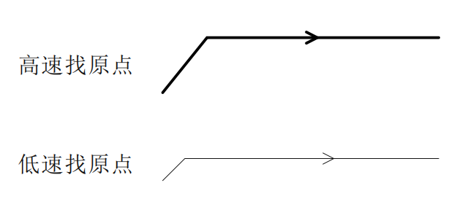

**Note:**In the following schematic diagrams defining all return-to-zero methods, movement to the right is positive movement, and movement to the left is negative movement.

**5.5.1 Mode 17 (Negative limit return to zero)**

'Negative limit return to zero'The origin stop position is at the negative limit signal.

'Negative limit return to zero'The whole action is divided into two cases, as follows:

Case A: The drive receives'Return to origin enable signal'After the command,'Return to origin speed V1','Acceleration and deceleration time when returning to origin'Several parameters start to move, and when they encounter the rising edge of the limit signal, they slow down and stop.'The return to origin speed V2' runs in the opposite direction until it encounters the falling edge of the limit signal, then decelerates and stops, and the entire return to zero action is completed.

Case B: The driver receives'Return to origin enable signal'After the command is given, if it is within the limit, it will'Return to origin speed V2','Acceleration and deceleration time when returning to origin'The parameter starts to move, and when it encounters the falling edge of the limit signal, it decelerates and stops, and the entire return to zero action is completed.

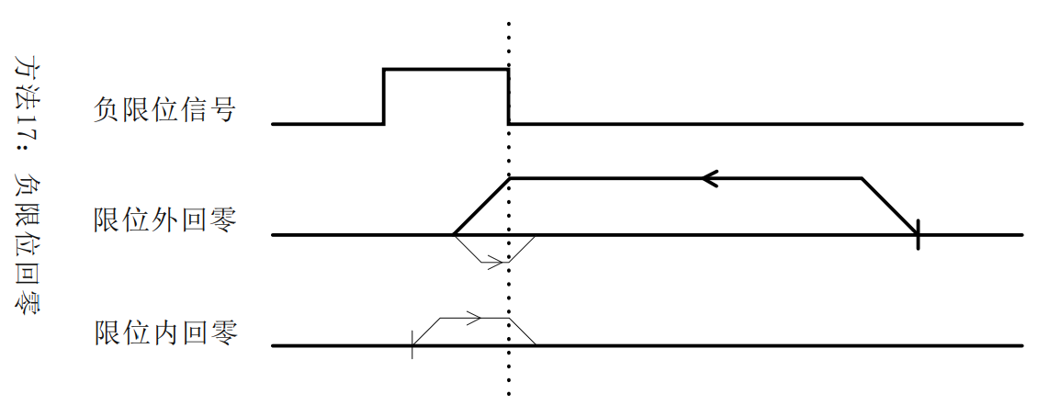

**5.5.2 Mode 18 (Positive limit return to zero)**

'Positive limit return to zero'The origin stop position is at the positive limit signal.

'Positive limit return to zero'and'Negative limit return to zero'Similar, except that the running direction is opposite, which will not be explained in detail here.

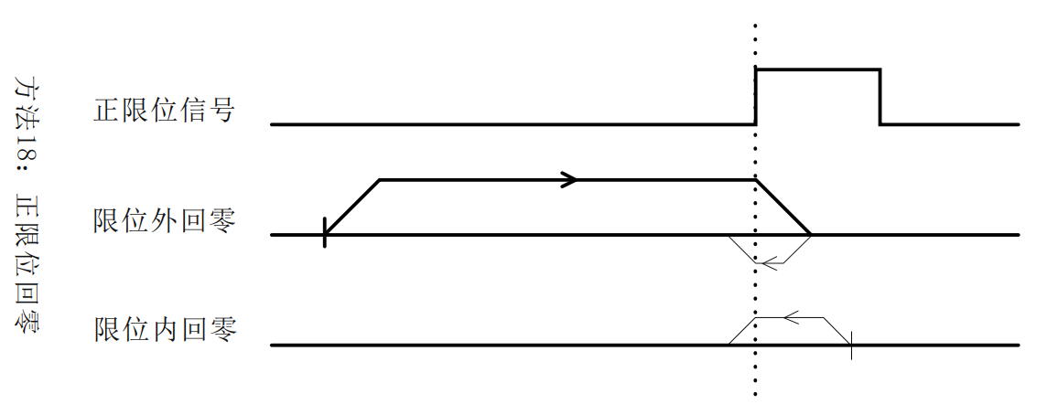

**5.5.3 Mode 19 (origin return 1)**

'The origin stop position of origin return 1' is on the left side of the rising edge of the origin signal in the positive direction.

'The whole action of returning to zero 1' can be divided into two cases, as follows:

Case A: The drive receives'Return to origin enable signal'After the command,'Return to origin speed V1','Acceleration and deceleration time when returning to origin'Several parameters move in the positive direction, and when they encounter the rising edge of the origin signal, they decelerate and stop.'The return to origin speed V2' runs in the opposite direction until it encounters the falling edge of the origin signal, then decelerates and stops, and the entire return to zero action is completed.

Case B: The driver receives'Return to origin enable signal'After the command is given, if the signal is in the origin, it will be'Return to origin speed V2','Acceleration and deceleration time when returning to origin'Several parameters move in the opposite direction, and when they encounter the falling edge of the origin signal, they decelerate and stop, and the entire return to zero action is completed.

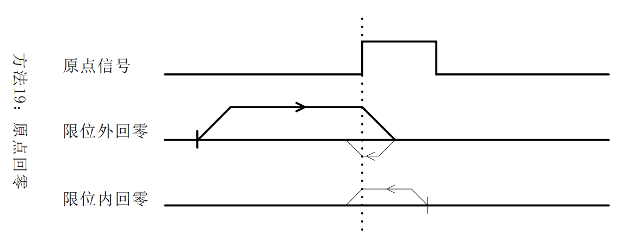

**5.5.4 Mode 20 (origin return 2)**

'The origin stop position of origin return 2' is on the right side of the rising edge of the origin signal in the positive direction.

'The whole action of returning to zero 2' is shown in the figure below. It will not be described in detail here.

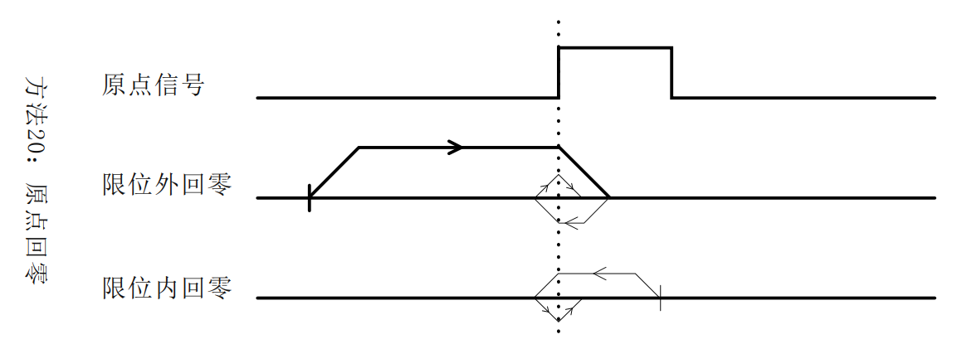

**5.5.5 Mode 21 (origin return 3)**

'The origin stop position of origin return 3' is on the right side of the rising edge of the origin signal in the reverse direction.

'The whole action of returning to zero 3' is'The origin return 1' is similar, except that the initial running direction is opposite. No detailed description is given here.

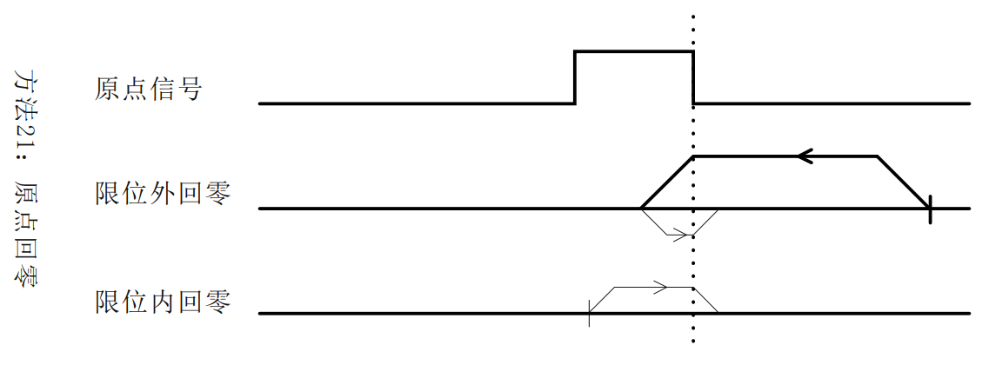

**5.5.6 Mode 22 (origin return 4)**

'The origin stop position of origin return 4' is on the left side of the rising edge of the origin signal in the reverse direction.

'The whole action of returning to zero 4' is'The origin return 2' is similar, except that the initial running direction is opposite. No detailed description is given here.

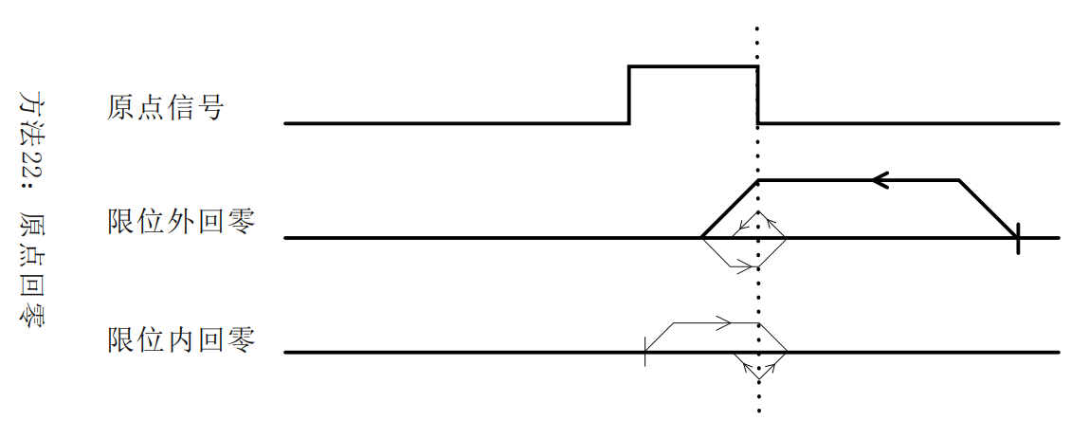

**5.5.7 Mode 23 (origin + positive limit return to zero 1)**

'The origin stop position of origin + positive limit return to zero 1' is on the left side of the rising edge of the origin signal in the positive direction.

'The whole action of origin + positive limit return to zero 1' is divided into three cases, as follows:

Case A: The drive receives'Return to origin enable signal'After the command,'Return to origin speed V1','Acceleration and deceleration time when returning to origin'Several parameters move in the positive direction, and when they encounter the rising edge of the origin signal, they decelerate and stop.'The return to origin speed V2' runs in the opposite direction until it encounters the falling edge of the origin signal, then decelerates and stops, and the entire return to zero action is completed.

Case B: The driver receives'Return to origin enable signal'After the command,'Return to origin speed V1','Acceleration and deceleration time when returning to origin'Several parameters move in the positive direction and stop immediately when they encounter the rising edge of the positive limit signal.'The return to origin speed V2' runs in the opposite direction until it encounters the falling edge of the origin signal, then decelerates and stops, and the entire return to zero action is completed.

Case C: The drive receives'Return to origin enable signal'After the command is given, if the signal is in the origin, it will be'Return to origin speed V2','Acceleration and deceleration time when returning to origin'Several parameters move in the opposite direction, and when they encounter the falling edge of the origin signal, they decelerate and stop, and the entire return to zero action is completed.

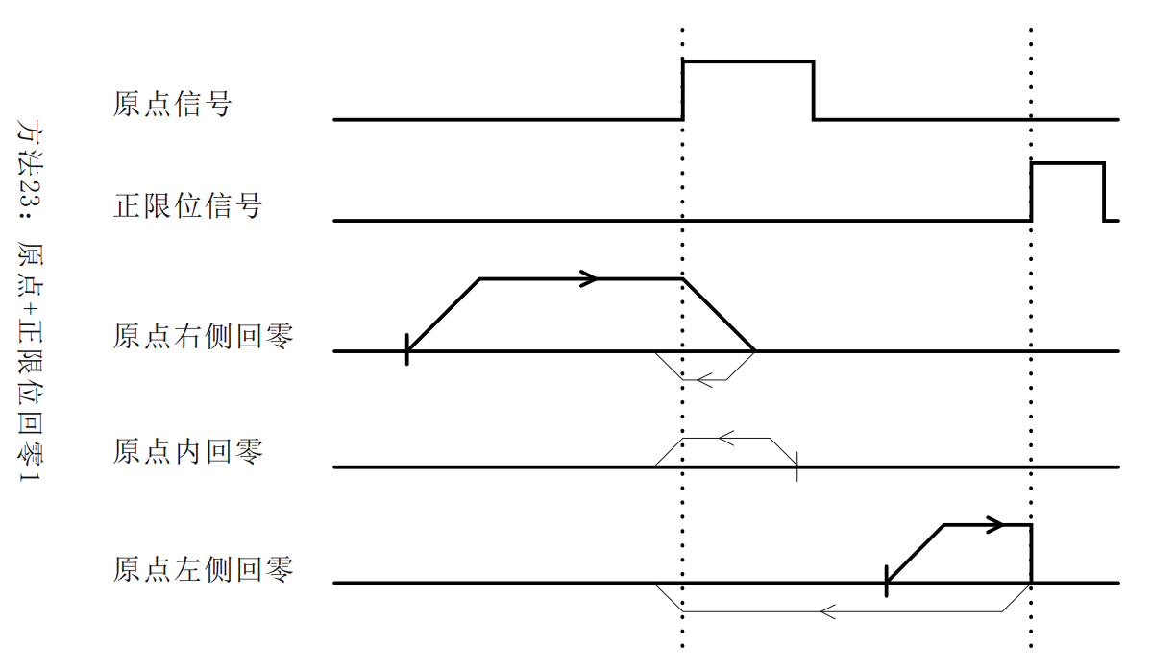

**5.5.8 Mode 24 (origin + positive limit return to zero 2)**

'The origin stop position of origin + positive limit return to zero 2' is on the right side of the rising edge of the origin signal in the positive direction.

'The whole action of origin + positive limit return to zero 2' is shown in the figure below. It will not be described in detail here.

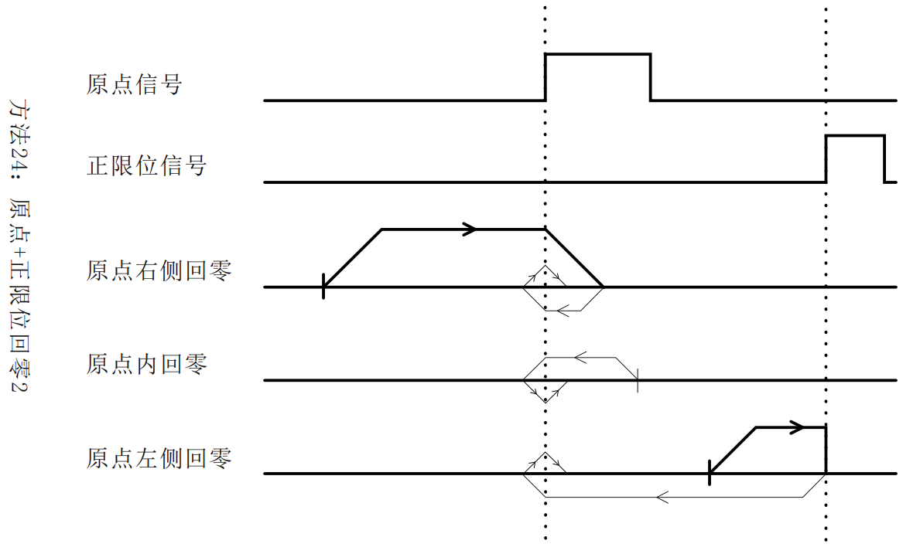

**5.5.9 Mode 25 (origin + positive limit return to zero 3)**

'The origin stop position of origin + positive limit return to zero 3' is on the left side of the falling edge of the origin signal in the positive direction.

'The whole action of origin + positive limit return to zero 1' is divided into three cases, as follows:

Case A: The drive receives'Return to origin enable signal'After the command,'Return to origin speed V1','Acceleration and deceleration time when returning to origin'Several parameters move in the positive direction. When encountering the rising edge of the origin signal, they continue to run. When encountering the falling edge of the origin signal, they decelerate and stop.'The return to origin speed V2' runs in the opposite direction until it encounters the rising edge of the origin signal, then decelerates and stops, and the entire return to zero action is completed.

Case B: The driver receives'Return to origin enable signal'After the command,'Return to origin speed V1','Acceleration and deceleration time when returning to origin'Several parameters move in the positive direction and stop immediately when they encounter the rising edge of the positive limit signal.'The return to origin speed V2' runs in the opposite direction until it encounters the rising edge of the origin signal, then decelerates and stops, and the entire return to zero action is completed.

Case C: The drive receives'Return to origin enable signal'After the command is given, if the signal is in the origin, it will be'Return to origin speed V1','Acceleration and deceleration time when returning to origin'Several parameters move in the positive direction, and when they encounter the falling edge of the origin signal, they decelerate and stop.'The return to origin speed V2' runs in the opposite direction until it encounters the rising edge of the origin signal, then decelerates and stops, and the entire return to zero action is completed.

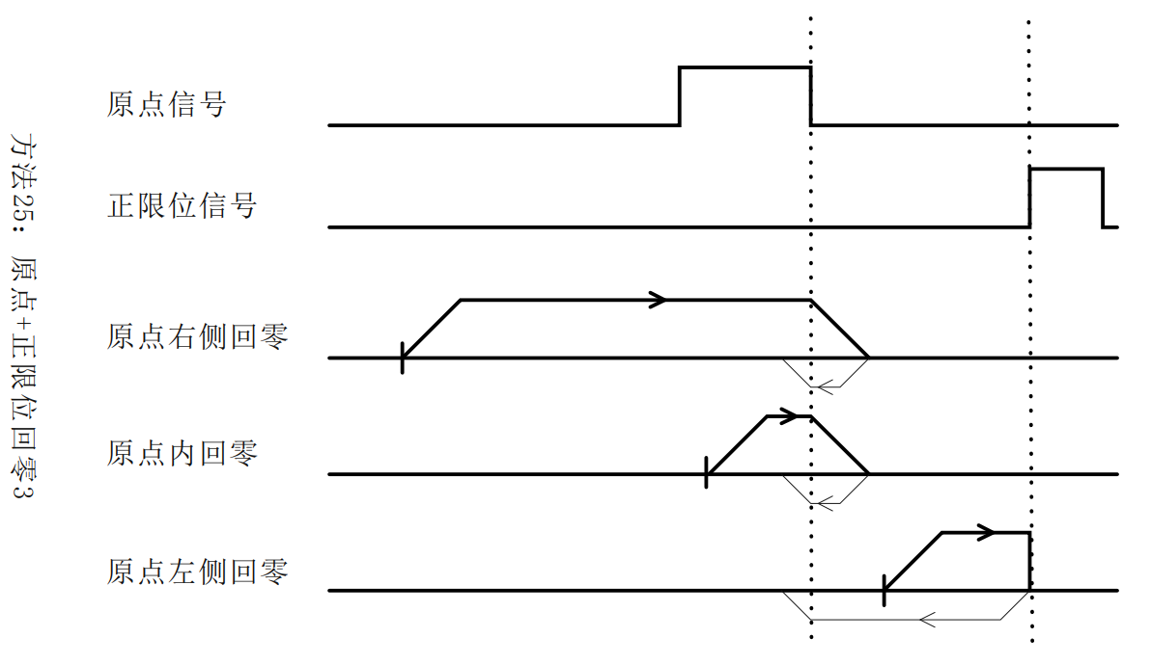

**5.5.10 Mode 26 (origin + positive limit return to zero 4)**

'The origin stop position of origin + positive limit return to zero 4' is on the right side of the falling edge of the origin signal in the positive direction.

'The whole action of origin + positive limit return to zero 4' is shown in the figure below. It will not be described in detail here.

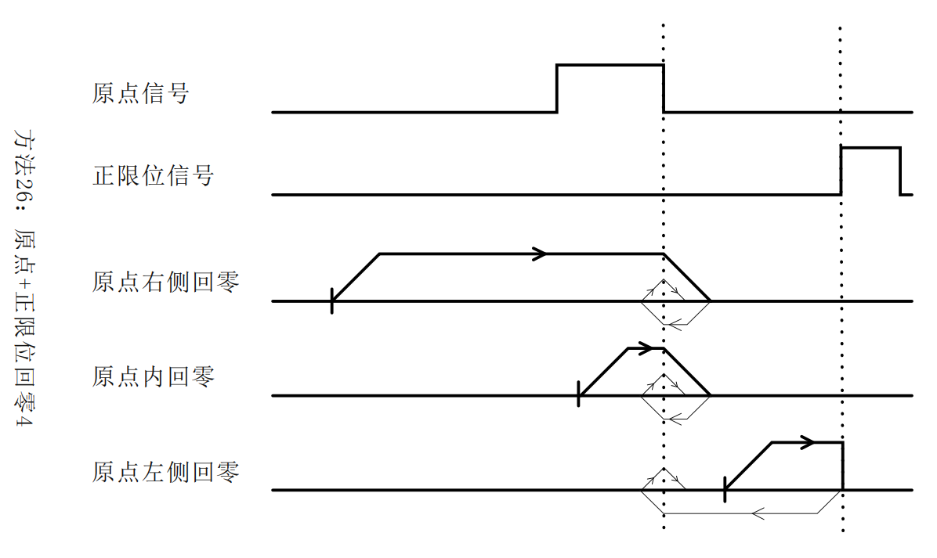

**5.5.11 Mode 27 (origin + negative limit return to zero 1)**

'The origin stop position of origin + negative limit return to zero 1' is on the right side of the rising edge of the origin signal in the reverse direction.

'The whole action of origin + negative limit return to zero 1' follows'The origin + positive limit return to zero 1' is similar, except that the initial running direction is opposite. No detailed description is given here.

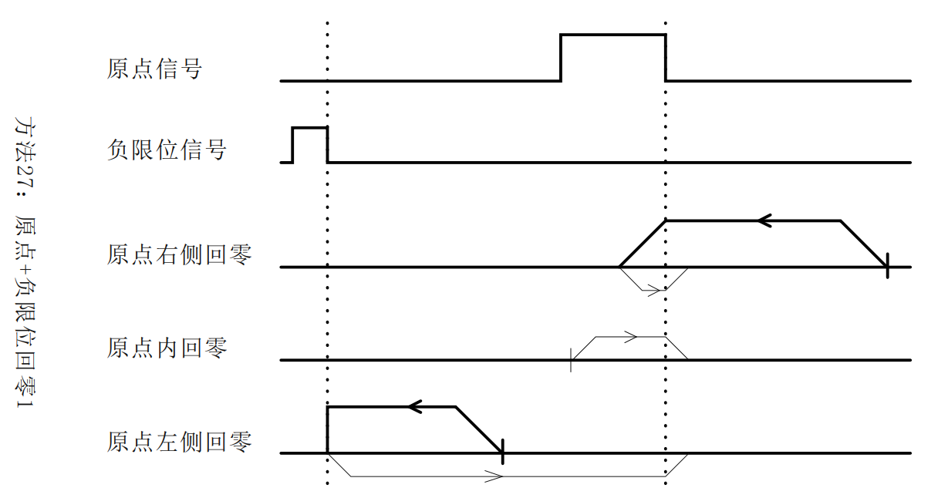

**5.5.12 Mode 28 (origin + negative limit return to zero 2)**

'The origin stop position of origin + negative limit return to zero 2' is on the left side of the rising edge of the origin signal in the reverse direction.

'The whole action of origin + negative limit return to zero 2' follows'The origin + positive limit return to zero 2' is similar, except that the initial running direction is opposite. No detailed description is given here.

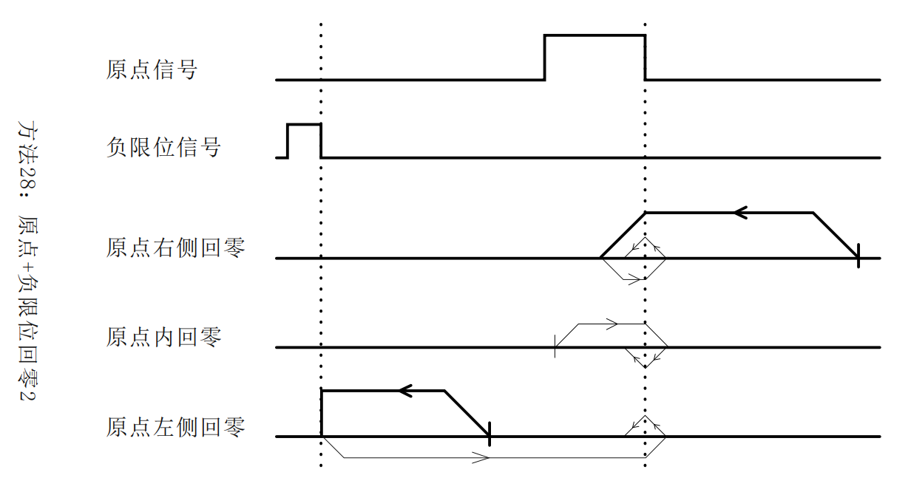

**5.5.13 Mode 29 (origin + negative limit return to zero 3)**

'The origin stop position of origin + negative limit return to zero 3' is on the right side of the falling edge of the origin signal in the reverse direction.

'The whole action of origin + negative limit return to zero 3' follows'The origin + positive limit return to zero 3' is similar, except that the initial running direction is opposite. No detailed description is given here.

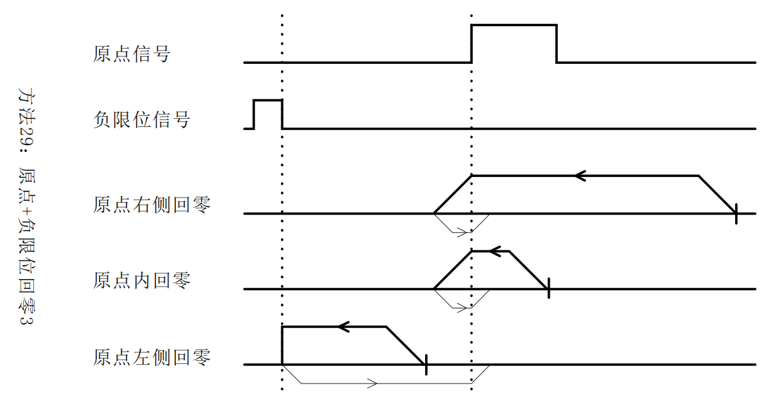

**5.5.14 Mode 30 (origin + negative limit return to zero 4)**

'The origin stop position of origin + negative limit return to zero 4' is on the left side of the falling edge of the origin signal in the reverse direction.

'The whole action of origin + negative limit return to zero 4' follows'The origin + positive limit return to zero 4' is similar, except that the initial running direction is opposite. No detailed description is given here.

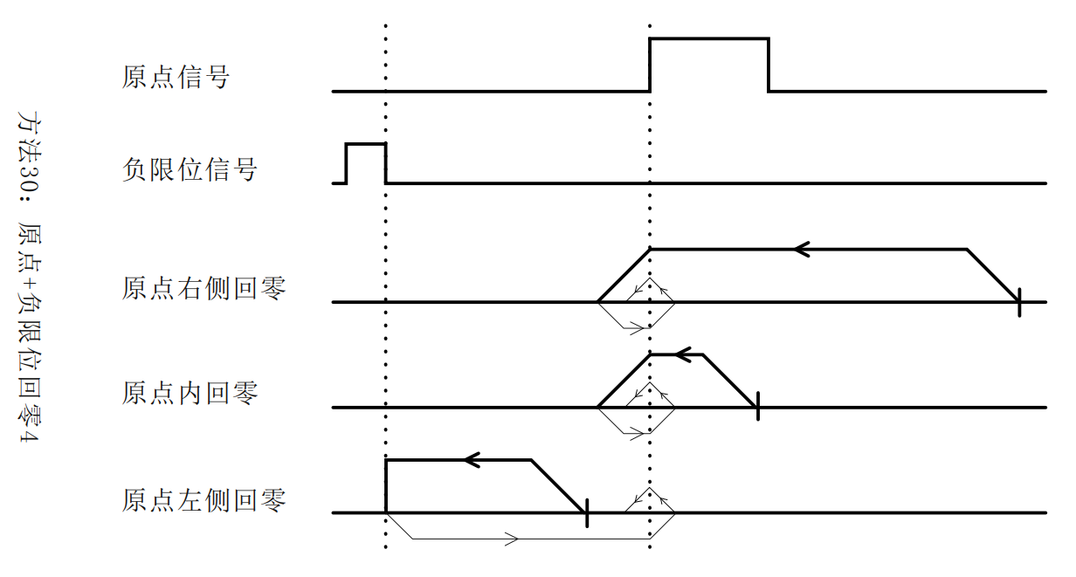

**5.5.15 Mode 33 (Z signal return to zero 1)**

This zero return method uses the Z signal as the zero return detection signal.'Negative limit return to zero'The directions are consistent, and the origin stop position is on the right side of the Z signal.

'The entire action of the Z signal returning to zero 1' is shown in the figure below. No detailed description is given here.

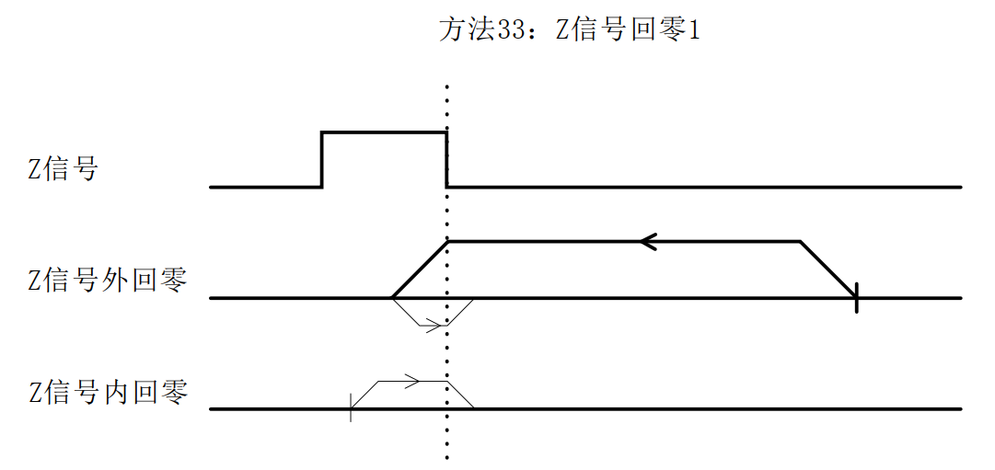

**5.5.16 Mode 34 (Z signal return to zero 2)**

This zero return method uses the Z signal as the zero return detection signal.'Positive limit return to zero'The directions are consistent, and the origin stop position is on the left side of the Z signal.

'The entire action of the Z signal returning to zero 2' is shown in the figure below. It will not be described in detail here.

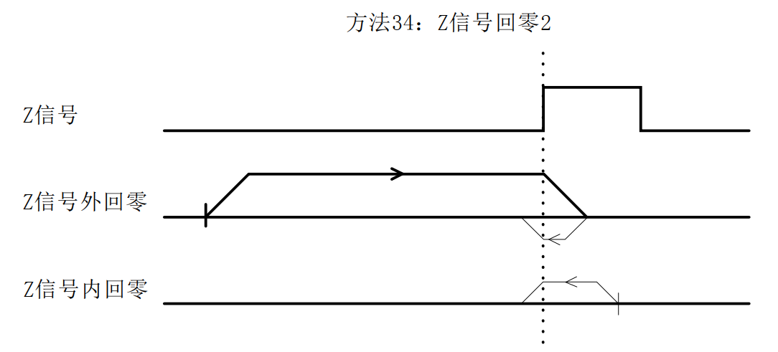

**5.5.17 Method -3 (blocked rotor return to zero 1)**

The motor starts with'The homing speed V1' runs in the positive direction. After a stall occurs, it decelerates to stop and moves in the reverse direction. After the dynamic torque of the motor disappears, it decelerates to stop and takes this position as the origin.

The entire action of this zero return method is shown in the figure below. No detailed description is given here.

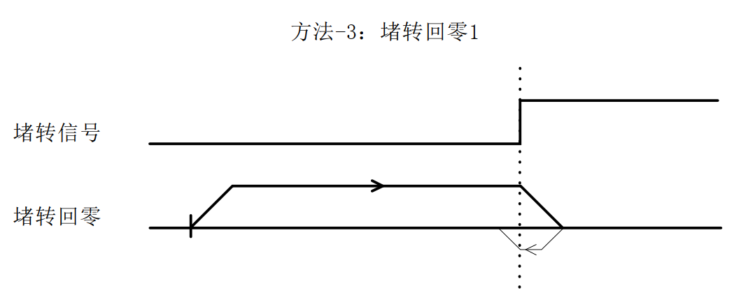

**5.5.18 Method -4 (blocked rotor return to zero 2)**

The motor starts with'The return speed is V1' and runs in the reverse direction. After a stall occurs, it decelerates to stop and moves in the reverse direction. After the dynamic torque of the motor disappears, it decelerates to stop and takes this position as the origin.

The entire action of this zero return method is shown in the figure below. No detailed description is given here.

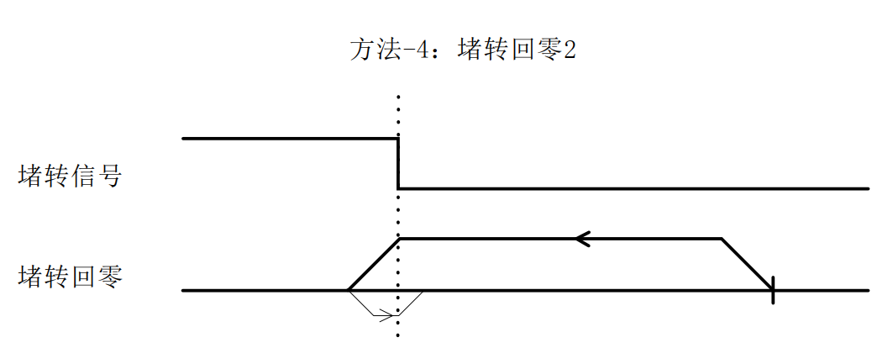

**5.5.19 Method -5 (blocked rotor return to zero 3)**

The motor starts with'The homing speed is V1' and the machine runs in the positive direction. If a stall occurs, it stops immediately and takes this position as the origin.

The entire action of this zero return method is shown in the figure below. No detailed description is given here.

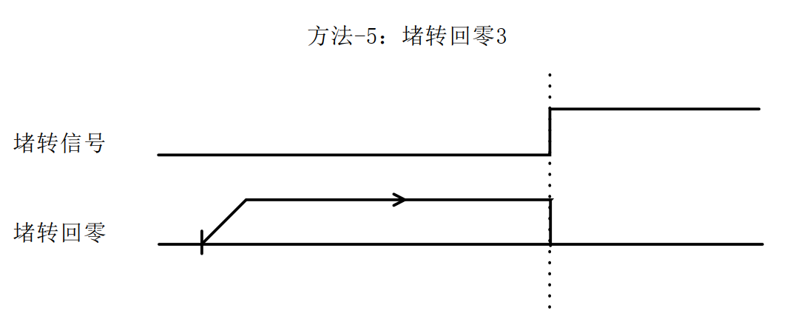

**5.5.20 Method -6 (blocked rotor return to zero 4)**

The motor starts with'The return speed V1' runs in the reverse direction. When a stall occurs, it stops immediately and takes this position as the origin.

The entire action of this zero return method is shown in the figure below. No detailed description is given here.

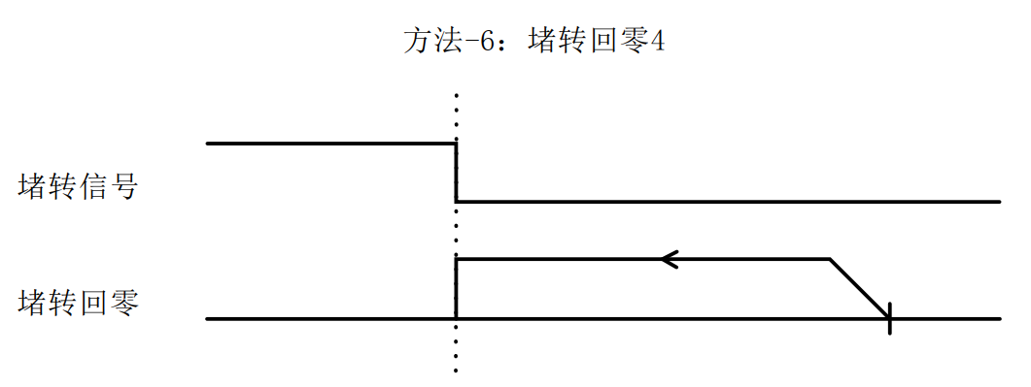

**5.5.21 Introduction to other zero return methods**

The above section introduces the return to zero methods 17-30, 33, 34, (-3)-(-6). The remaining return to zero methods are similar to the above return to zero methods. The corresponding relationships are shown in the following table:

|  |  |  |
| --- | --- | --- |
| Zero return method | Similar return to zero method | describe |
| 1 | 17 | After finding the positive and negative limits or the origin limit, continue running and take the first detected Z signal as the zero position; |
| 2 | 18 |
| 3 | 19 |
| 4 | 20 |
| 5 | twenty one |
| 6 | twenty two |
| 7 | twenty three |
| 8 | twenty four |
| 9 | 25 |
| 10 | 26 |
| 11 | 27 |
| 12 | 28 |
| 13 | 29 |
| 14 | 30 |
| -1 | 3 |
| -2 | 4 |
| 35, 37 | none | Take the current position as the zero position; |

# **Serial port download parameter description**

For details, please refer to the document "EC57-K01 Serial Download Communication Protocol Manual".

# **Fault codes and indicators**

## 7.1 Drive Failure

|  |  |  |  |  |  |  |
| --- | --- | --- | --- | --- | --- | --- |
| **603F Code** | **1001 Code** | **meaning** | **201C Code** | **Removability** | **201B corresponding position** | **LED Flashing** |
| 0x2211 | 0x02 | Overcurrent fault | 0x0E0 | no | Bit0 | 1 time |
| 0x4211 | 0x04 | Busbar overvoltage | 0x0C0 | no | Bit1 | 2 times |
| 0x5110 | 0x80 | Motor A phase is missing | 0x210 | no | Bit1 | 3 times |
| 0x5120 | 0x80 | Motor B phase is missing | 0x210 | no | Bit1 | 3 times |
| 0x8402 | 0x20 | Command overspeed | 0x1A0 | yes | Bit2 | 4 times |
| 0x5530 | 0x80 | Failure to save parameters | 0x240 | yes | Bit3 | 3 times |
| 0x8403 | 0x20 | The command pulse increment within the PWM cycle is too large | 0x1A1 | yes | - | 4 times |
| 0x8401 | 0x20 | Location out of tolerance | 0x1A2 | no | - | 4 times |
| - | - | Hardware interrupt protection | - | - | - |  |

Writing 1 to 201E can clear the current alarm;

Writing 1 to 201D can clear the fault record, that is, clear the fault list of 201B;

## 7.2 EtherCAT communication alarm

According to the EtherCAT ALM status code definition, some error codes are listed below.

|  |  |  |  |  |  |
| --- | --- | --- | --- | --- | --- |
| **603F Code** | **1001 Code** | **meaning** | **201C** | **Removability** | **LED Flashing** |
| 0x8213 | 0x10 | No BOOT support |  | 1 | 4 times |
| 0x8215 | 0x10 | BOOT mode configuration is invalid |  | 1 | 4 times |
| 0x8216 | 0x10 | Invalid mailbox configuration |  | 1 | 4 times |
| 0x8217 | 0x10 | Invalid SM configuration |  | 1 | 4 times |
| 0x821B | 0x10 | SM watchdog timeout | 0x101B | 1 | 4 times |
| 0x821C | 0x10 | Invalid SM type | 0x101C | 1 | 4 times |
| 0x821D | 0x10 | Invalid output configuration |  | 1 | 4 times |
| 0x821E | 0x10 | Invalid input configuration |  | 1 | 4 times |
| 0x821F | 0x10 | Invalid watchdog configuration |  | 1 | 4 times |
| 0x821A | 0x10 | Synchronous mode error | 0x101A | 1 | 4 times |
| 0x8230 | 0x10 | Invalid DC configuration |  | 1 | 4 times |
| 0x8232 | 0x10 | DC PLL Error | 0x1032 | 1 | 4 times |
| 0x8233 | 0x10 | DC synchronous IO error | 0x1033 | 1 | 4 times |
| 0x8234 | 0x10 | DC Sync Timeout | 0x1034 | 1 | 4 times |
| 0x8211 | 0x10 | Invalid state change request | 0x1011 | 1 | 4 times |
| 0x8212 | 0x10 | Unknown state change request | 0x1012 | 1 | 4 times |
| 0x8221 | 0x10 | The slave needs the Init state | 0x1021 | 1 | 4 times |
| 0x8222 | 0x10 | The slave needs to be in Pre-Op state | 0x1022 | 1 | 4 times |
| 0x8223 | 0x10 | The slave needs the Safe-OP state | 0x1023 | 1 | 4 times |

# **Warranty and after-sales**

## **8.1 Warranty**

**8.1.1 Free warranty**

Our company solemnly promises that for all products purchased from our company, if they are damaged due to the product itself during use, we will provide one year of free repair service. The round-trip shipping cost of the product shall be borne by both parties in half.

**8.1.2 Warranty exclusion**

1. The driver is damaged due to the customer's own wiring error;
2. The drive is damaged due to exceeding the rated working voltage;
3. The DC power supply driver is connected to the AC power supply, causing the driver to be damaged;
4. The driver is damaged due to the customer's extremely harsh on-site environment, such as humidity, extreme cold, extreme heat, etc., without informing our company in advance;
5. The customer dismantles the drive housing without permission or the serial label number is torn off;
6. 15 days after the customer confirms receipt, the housing is obviously damaged or hit, resulting in damage to the drive;
7. Forceful natural disasters, such as fire, earthquake, tsunami, typhoon, etc.;

In the above cases, our company will charge a certain amount of repair cost after evaluating the interests of all parties. In other cases, repairs will be provided free of charge forever.

## **8.2 Exchange**

**8.2.1 Product replacement due to product failure**

For faults in new products, our company provides three months of free replacement service.

After our technical support staff confirms that the problem is with the product itself, they will send the product back to our company to avoid wasting time and postage on the round trip. Customers need to send the faulty product back by express or logistics first, and our company will send another new product back to the customer as soon as possible after receiving it.

**Notice:**All our products undergo rigorous testing and aging before leaving the warehouse, so it is extremely rare for new products to malfunction. Please be sure to read the instructions carefully or consult our technical support staff when operating, or our technical support staff will remotely assist customers in operating.

* **Please note the following points when exchanging goods:**

(1) Please ensure that the package is complete when sending it back to avoid damage during transportation;

(2) Please ensure that the attached accessories are complete when exchanging the product;

(3) Each driver should be packaged independently in its original outer box to avoid secondary damage to the product during transportation;

(4) If the driver is returned and it is confirmed that the fault is not due to product failure, but rather due to the customer's negligence in operation, which led to the customer mistakenly thinking that the driver is faulty, the company will not bear the shipping costs (the customer's negligence in operation includes: the driver is damaged due to wrong wiring, the driver is mistakenly thought to be damaged due to poor wiring, the driver cannot be used normally due to operation errors, etc.).

**8.2.2 Replacement for non-product failure**

If the customer is not satisfied with the appearance or function of the product received and wants to replace it with a better driver, he or she can apply for a replacement service from our company within one week of receiving the product. After verification, our company will return the product. If the returned product is confirmed to be undamaged, with complete accessories and good packaging, the company will replace it with another product for the customer. For the replaced product, if there is a price difference, the customer will make up the difference.

**Note: The replaced product will no longer be eligible for the non-product fault replacement service. The round-trip shipping costs and other costs incurred by the non-product fault replacement service shall be borne by the customer!**

## **8.3 Returns**

Our company provides a 7-day return service for products with quality problems. If you find quality problems with the product within 7 days of receiving the product (based on the actual date of receipt by the customer), please communicate with our salesperson or technical support personnel in time. After our technical support personnel confirms that it is a quality problem of the company's product itself, the customer can send the original complete product and its inner and outer packaging, accessories and shipping order back to our company by express or logistics.

If the customer still insists on returning the goods after our company has checked and confirmed that they are correct, the round-trip shipping costs and all other costs incurred shall be borne by the customer.

* **Please note the following points when returning goods:**

(1) Please contact the relevant department of our company before making a refund;

(2) The product must be in new condition and intact packaging. Please send it back to our company by express or logistics;

(3) We will not accept any complaints caused by customers, such as product appearance damage, incomplete accessories, etc.

## **8.4 After-sales service**

If customers encounter technical problems when using this product, please contact our company as soon as possible. Please call our national free service hotline: 0755-23206995.

Service hours: 8:30-17:30, Monday to Saturday (except national holidays).

# **Revision History**

|  |  |  |  |
| --- | --- | --- | --- |
| **Version Number** | **illustrate** | **Modify deadline** | Preparer/Reviewer |
| V1.0.0 | EC57-K01 series initial manual version; | 2023.9.27 | TCJ/XH |